**Python Programming Set-Up**

**Install Anaconda 5.1 – Python 3.6 (before practical)**

1. Go to: [www.anaconda.com/download](http://www.anaconda.com/download)
2. Scroll down, choose your operating system (Windows or MacOS)
3. Hit the big green button
4. **Windows people**: when you get to ‘Advanced Installation Options’, tick the box that says ‘Add Anaconda to my PATH environmental variable’.
5. **Do this prior to the practical**: the download and installation will take up to an hour

Anaconda is a package manager, an environment manager, a Python distribution and a collection of hundreds of open-source packages such as NumPy, SciPy, Matplotlib and Jupyter Notebook.

For more information: [docs.anaconda.com/_downloads/Anaconda-Starter-Guide-Cheat-Sheet.pdf](https://docs.anaconda.com/_downloads/Anaconda-Starter-Guide-Cheat-Sheet.pdf)

**Launch Jupyter Notebook through the Anaconda Prompt**

The Anaconda Prompt is a command line interpreter used to execute entered commands. You already have the Windows Command Prompt or MacOS Terminal on your computers, which can be used similarly. If you are interested: [www.lifewire.com/list-of-command-prompt-commands-4092302](http://www.lifewire.com/list-of-command-prompt-commands-4092302). Command Prompts offer a lot of functionality but we will only be using them to manage files and launch Jupyter Notebook.

Jupyter Notebook (formally IPython notebook, hence .ipynb) allows us to create Python Notebooks, which contain computer code and rich text elements (paragraphs, titles, links, figures etc). This allows us to display code, comments, figures and other output together. What’s more, individual blocks of code can be run as opposed to the whole code – which can save a lot of processing time.

Below is an example Notebook containing text, an equation, code and the figures produced:

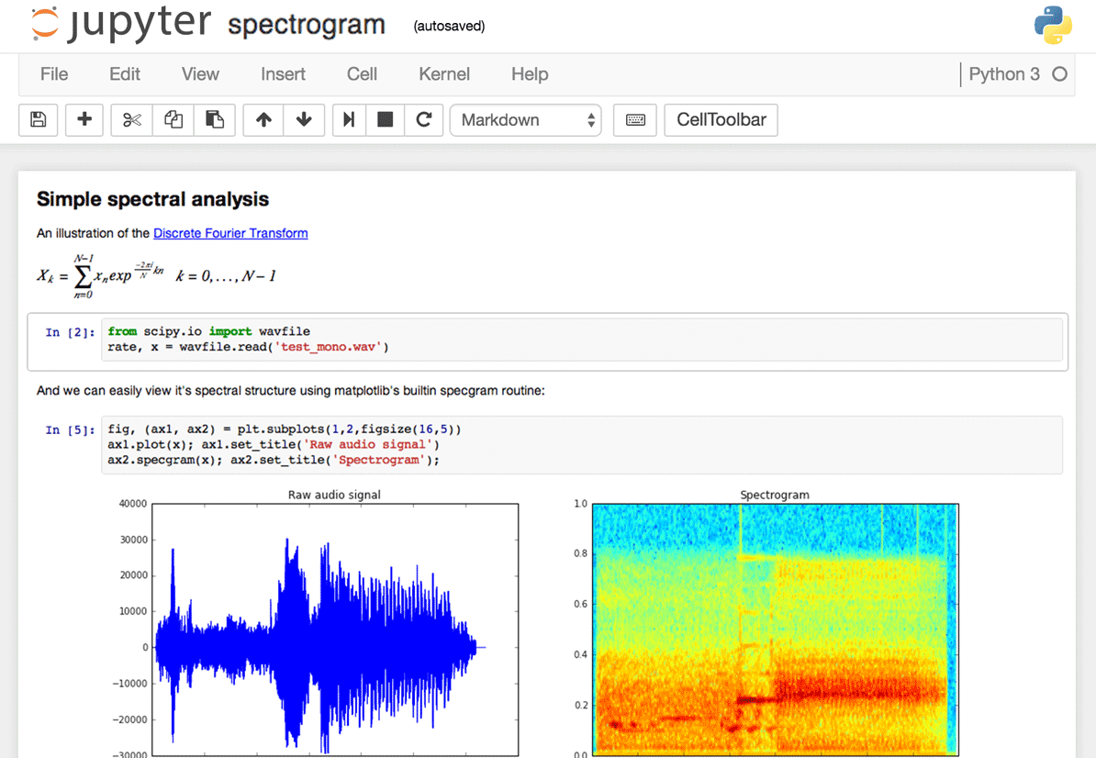

1. Start the Anaconda Prompt

* Windows: Go to: Start > Search: Anaconda Prompt > Open
* MacOS: Go to: Spotlight Search > Search: Anaconda Prompt
* Once opened, the Anaconda Prompt will look like this:

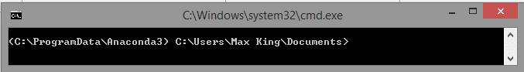

1. 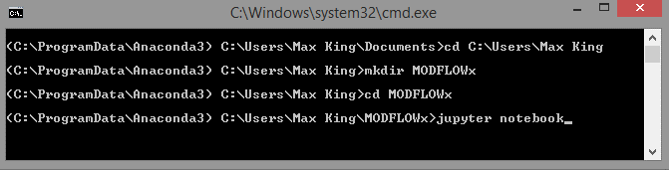Change directory (**cd**) into your User directory then make a directory (**mkdir**) to host your files, call it ‘**MODFLOW’**. This is the same as navigating around your File Explorer or Finder. Once you have made the directory, change directory into it and launch jupyter notebook by entering the command: ‘**jupyter** **notebook’**.
2. Wait for Jupyter Notebook to launch in your browser. The Anaconda Prompt will look something like this:

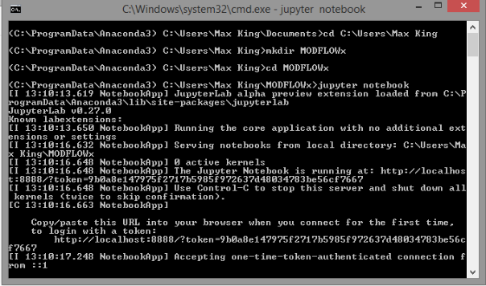

1. Your Jupyter Notebook will look like this:

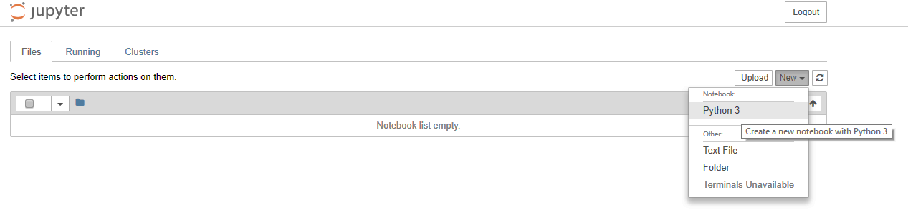

1. The Notebook list is empty because you have just opened Jupyter Notebook in an empty folder. Make a new Notebook with Python 3.

You can now code using Python and Jupyter Notebook!

Take a look at the **Introduction to Python and Jupyter Notebook** we have created for you. There is a range of exercises to try out prior to starting the course. We recommend that you get familiar with the basic syntax of Python and learn how to use a Jupyter Notebook.

**Get started on GitHub**

GitHub is a web-based hosting service for version control and collaboration, mostly used for developing computer code. It is widely used in industry and a useful skill to learn. We will be using it to distribute and collect your practical material.

1. Before each practical you will be invited to join a repository containing the practical material, called ‘UoB-Applied-Hydrogeology-Practical-3’, for example.
2. You will clone this repository and make your own, called ‘UoB-Applied-Hydrogeology-Practical-3-ab12345’, for example.
3. You will then upload your completed work to this repository, which will be private and accessible only to the markers.

An interactive trial is provided: [guides.github.com/activities/hello-world/](https://guides.github.com/activities/hello-world/). I would recommend trying this out for yourself as you follow the instructions. You will need to make an account to perform the trial, so use your UoB username ([ab12345@my.bristol.ac.uk](mailto:ab12345@my.bristol.ac.uk)).

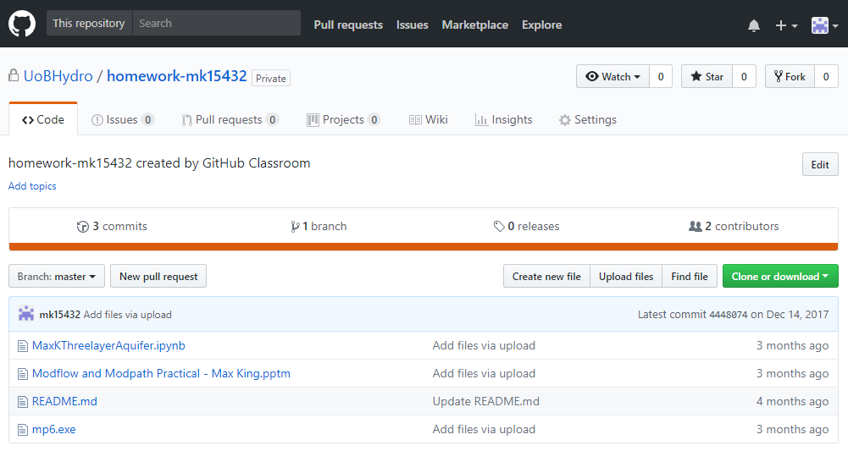

UoBHydro is the ‘classroom’, ‘homework-ab12345’ is the student’s private repository

.ipynb is the Python Notebook and .pptm is the Presentation uploaded by the student.

‘mp6.exe’ is an executable for MODFLOW

Upload files, Clone or download repository

**GitHub: Repositories, branches, commits and pull requests**

1. A *repository* can be thought of as a folder and can contain any file type (documents, presentations, images, Python Notebooks).
2. A *branch* can be thought of as a duplicate repository or folder. Your first branch is your *master-branch* and subsequent branches will be duplicates of this.
3. A *commit* is a saved change to a branch. Each has an associated *commit message* which explains the change, so that a history of changes can be followed. After a commit has been made to a *non-master-branch*, a pull request can be opened.
4. A *pull request* shows the *diffs*, or differences between the content from master and non-master-branches. Changes, additions and subtractions are shown in green or red. Each has an associated *comment* which explains the difference. Pull requests allow differences to be *merged* into the master-branch. Once a non-master-branch has been merged it can be deleted.

**Some useful links**

Largest online community for code developers to learn and share 🡪 [stackoverflow.com/](https://stackoverflow.com/)

NumPy and Matplotlib 🡪 [numpy.org/](http://www.numpy.org/) and [matplotlib.org/](https://matplotlib.org/)

Jupyter Notebook Tutorial: Introduction, Setup, and Walkthrough 🡪 [youtube.com/watch?v=HW29067qVWk](http://www.youtube.com/watch?v=HW29067qVWk)

Python for Earth Scientists 🡪 [homepages.see.leeds.ac.uk/~earawa/PythonEarthSci/](http://homepages.see.leeds.ac.uk/~earawa/PythonEarthSci/)